Assignment 8

1. mins Look at the data given below. Plot the data, find the outliers and find out Mean,Variance,Standard deviation

**Data Importing :**

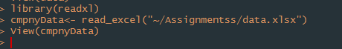

**Plotting the data**

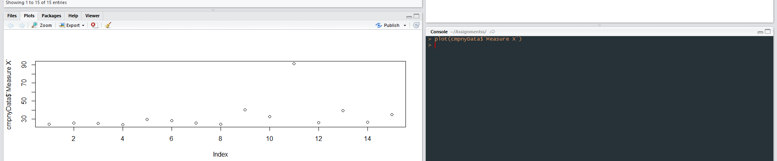

**Boxplot and outlier**

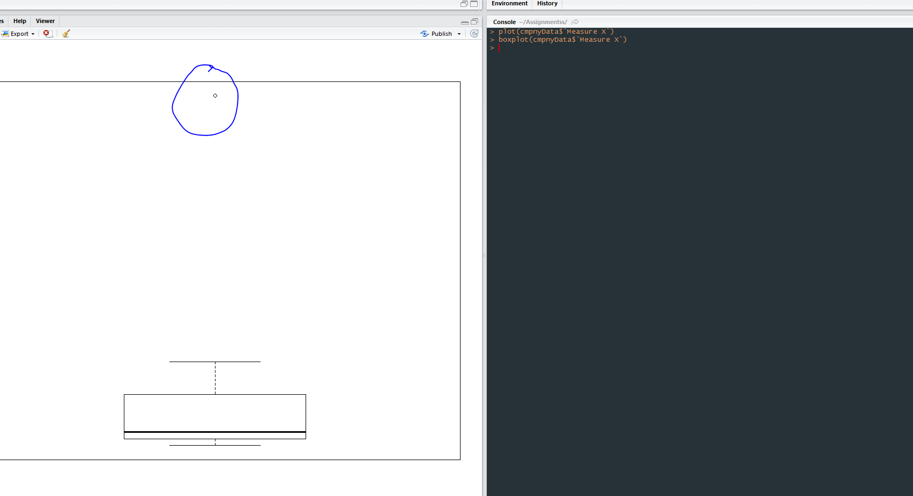

**Finding variance,SD,Avg**

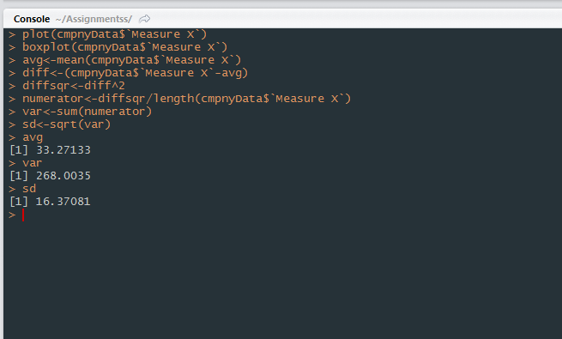

1. **Interqutile range : this value implies the range of 1st quartile to 3rd one**

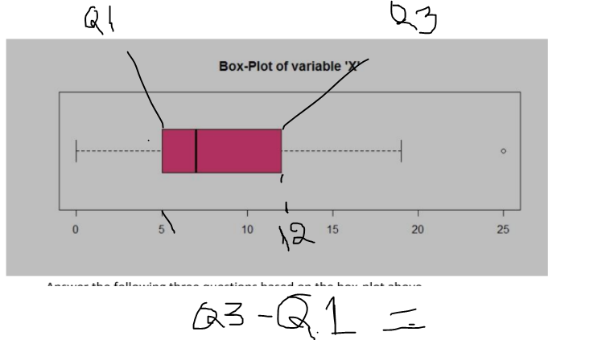

**12-5= 7,IQR is 7**

**(ii) What can we say about the skewness of this dataset?**

**Ans:Right Skewed dataset : as the data is more after the median.**

**(iii) If it was found that the data point with the value 25 is actually 2.5, how would**

**the new box-plot be affected?**

**Ans : The median will decrease and right skewness will increase.**

**No outlier**

**Max value will change to 19.**

**Q3:Answer the following three questions based on the histogram above.**

1. **Where would the mode of this dataset lie?**

**Ans : should be around 21**

1. **Comment on the skewness of the dataset.**

**Ans :Right skewed as most of the data is before median and mean is also before the median**

**(iii) Suppose that the above histogram and the box-plot in question 2 are plotted for**

**the same dataset. Explain how these graphs complement each other in providing**

**information about any dataset.**

**Ans :Both graphs are right skewed.**

**Max and Min value similar in both graphs**

**4. AT&T was running commercials in 1990 aimed at luring back customers who had switched to one of the other long-distance phone service providers. One suchcommercial shows a businessman trying to reach Phoenix and mistakenly getting Fiji,**

**where a half-naked native on a beach responds comprehensibly in Polynesian. When asked about this advertisement, AT&T admitted that the portrayed incident did not actually take place but added that this was an enactment of something that “could**

**happen.” Suppose that one in 200 long-distance telephone calls is misdirected. What is the probability that at least one in five attempted telephone calls reaches the wrong number? (Assume independence of attempts.)**

**Ans :**

probability that at least one in five attempted telephone calls reaches the wrong number =  
  
1 - probability that none of the five calls are misdirected   
= 1-(1-p)^5  
= 1 - (1-1/200)^5

=0.02475 proablity

**Q 5 –** **Returns on a certain business venture, to the nearest $1,000, are known to follow the**

**following probability distribution.**

1. **What is the most likely monetary outcome of the business venture?**

**Ans: 2000, as the highest probability is .3 for the 2000**

**(ii) Is the venture likely to be successful? Explain**

**Ans :**

**If the venture can maintain for long term business then eventually it will be successfulsince the probability of non-negative return is higher than 0.50 and the expected value forreturn is a positive number ($800)**

1. **What is the long-term average earning of business ventures of this kind? Explain**

**Ans : 800**

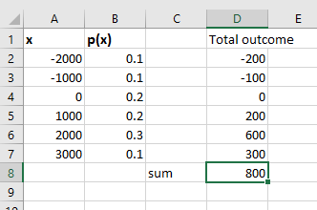

**(iv) What is the good measure of the risk involved in a venture of this kind? Compute**

**this measure**

**Ans :** 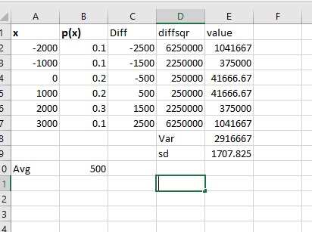

**Sd-** 1707